CAPSTONE PROJECT

**(TEAM 8)**

PROJECT TITLE

**Customer Feedback Management System**

Made by – Kancharla Deva Harshini

& Kartik Angrish

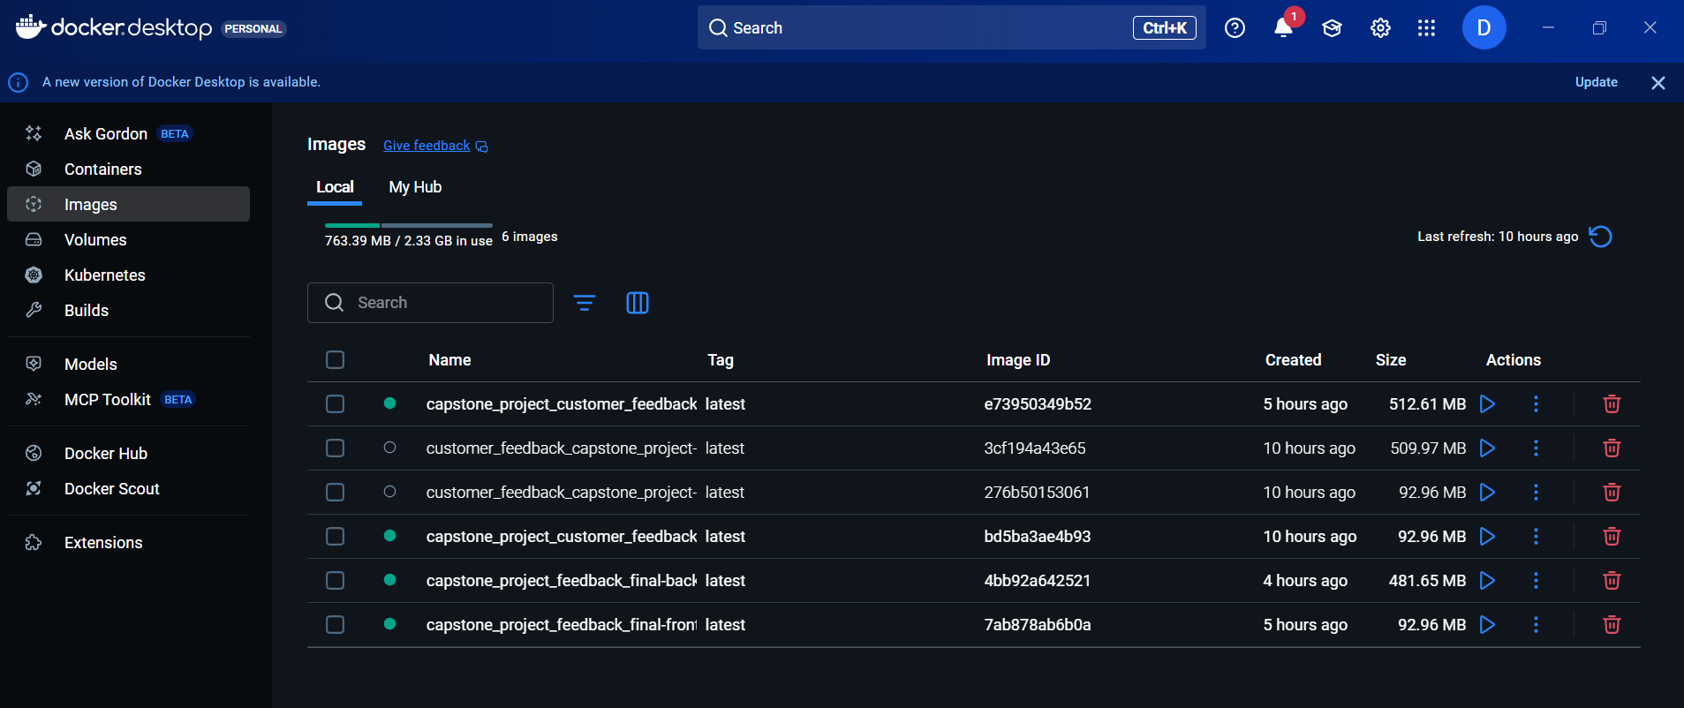

Docker Deployment of Frontend & Backend in Docker Desktop

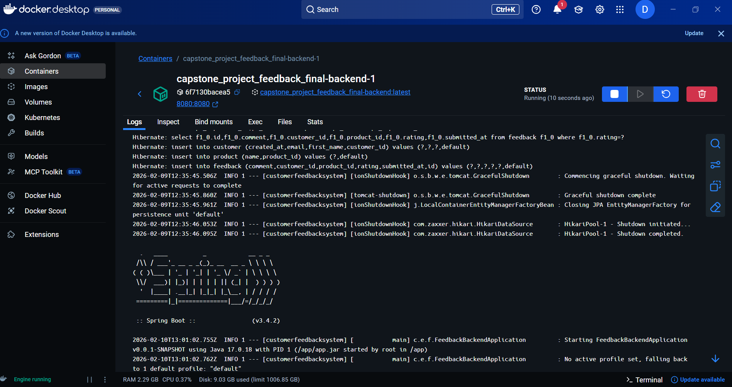

Running the Docker container (Logs of Backend)

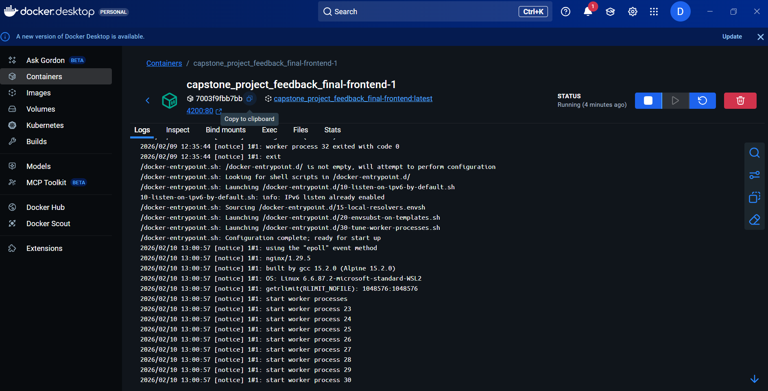

Running the Docker container (Logs of Frontend)

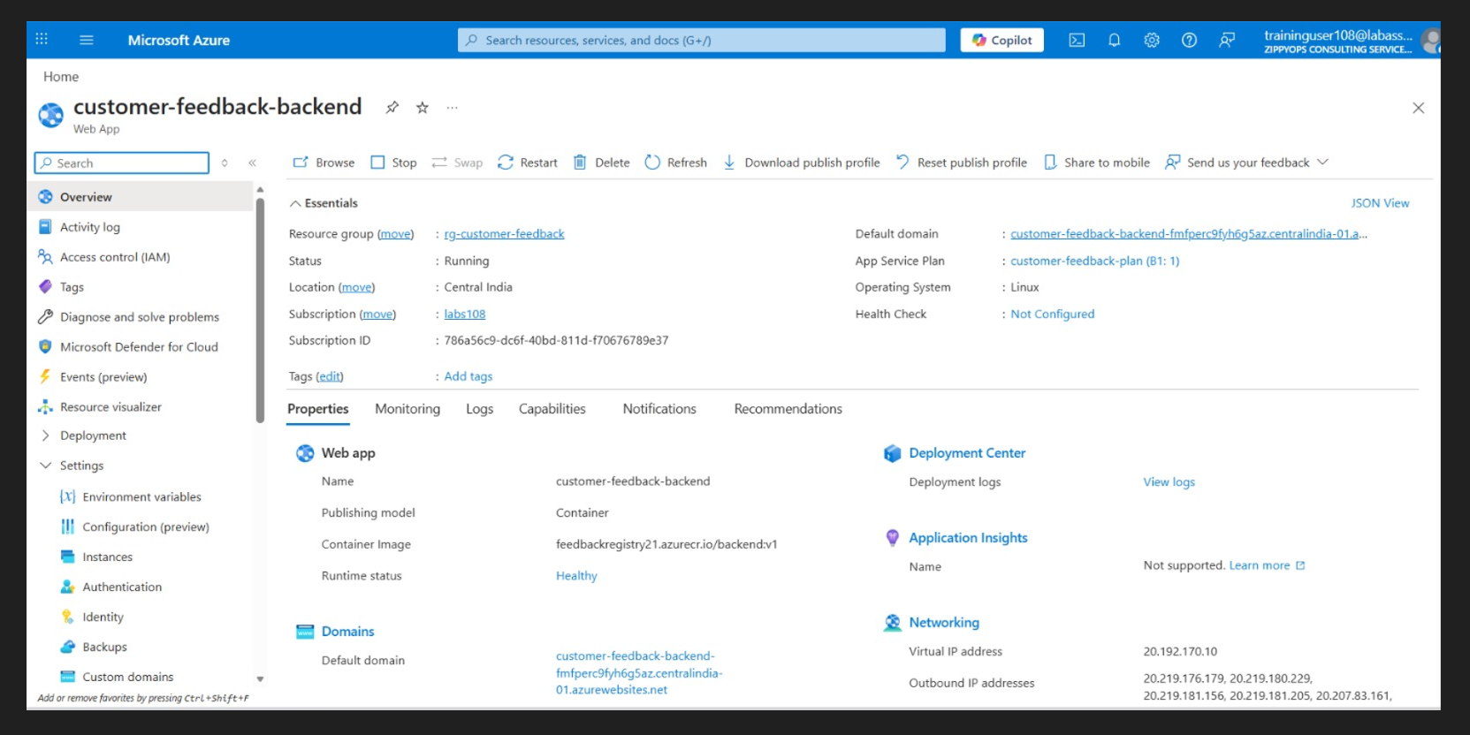

Successfully deployed the backend in Azure

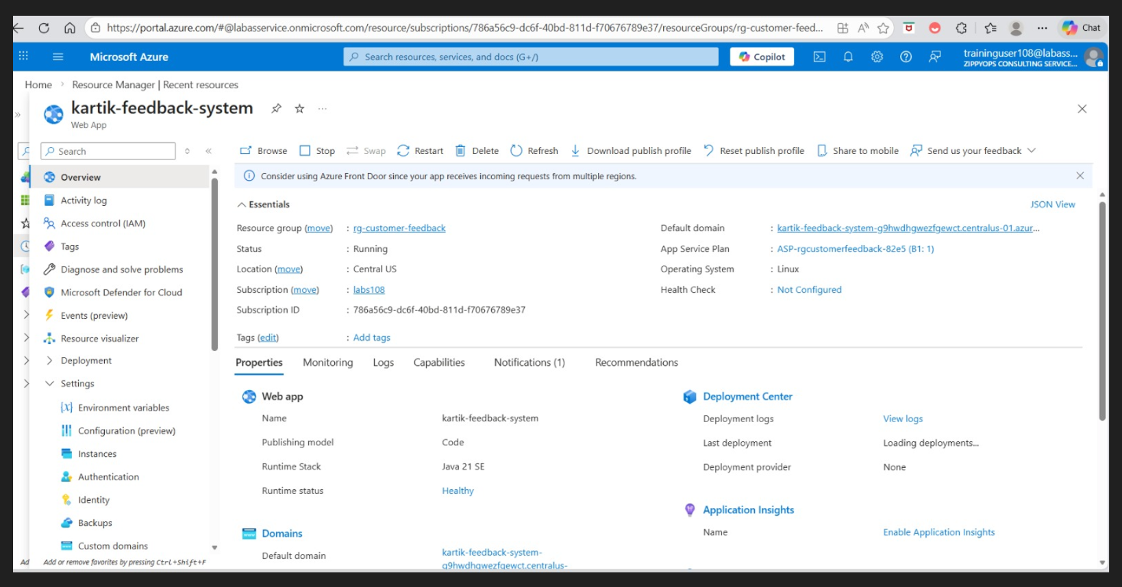

Successfully deployed the frontend in Azure

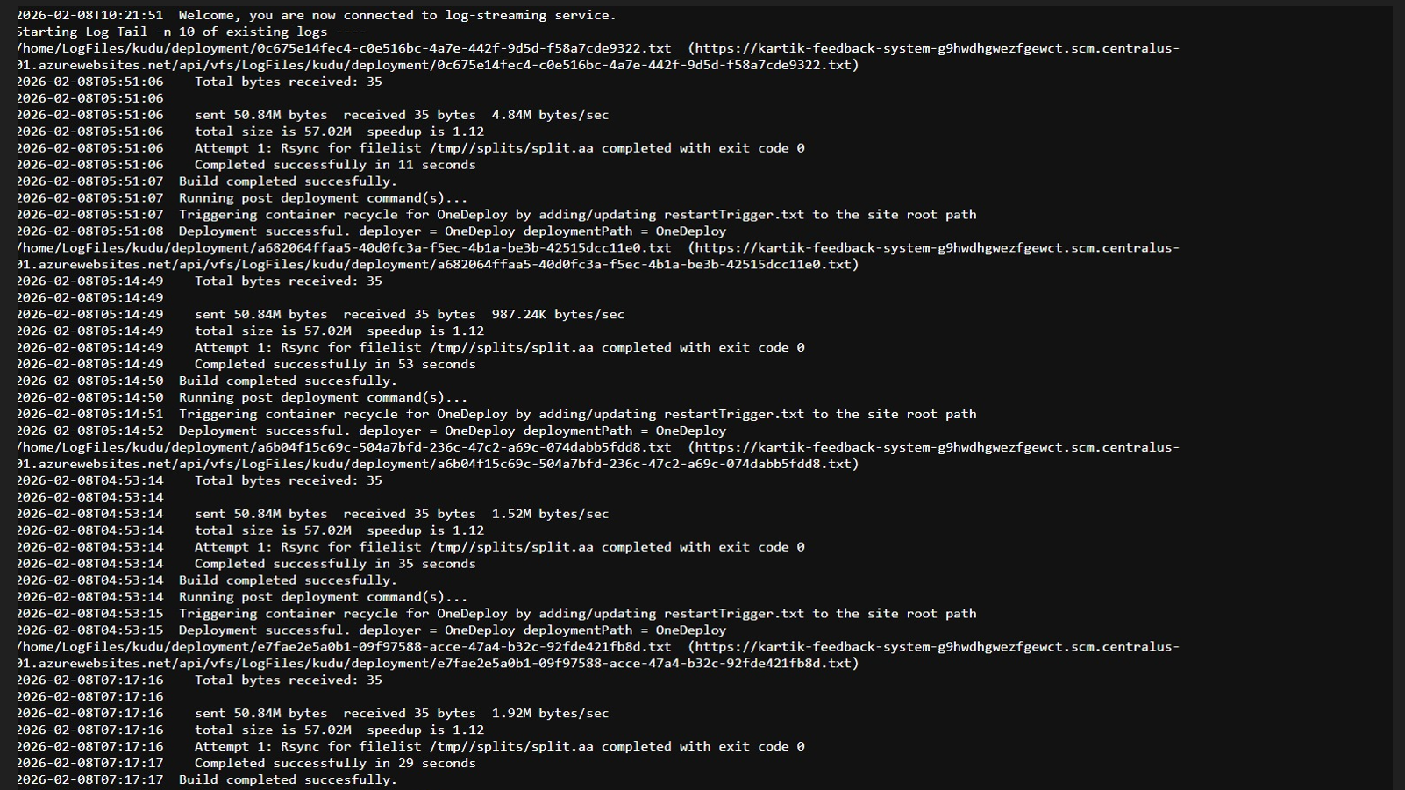

Logs of deployment for Azure

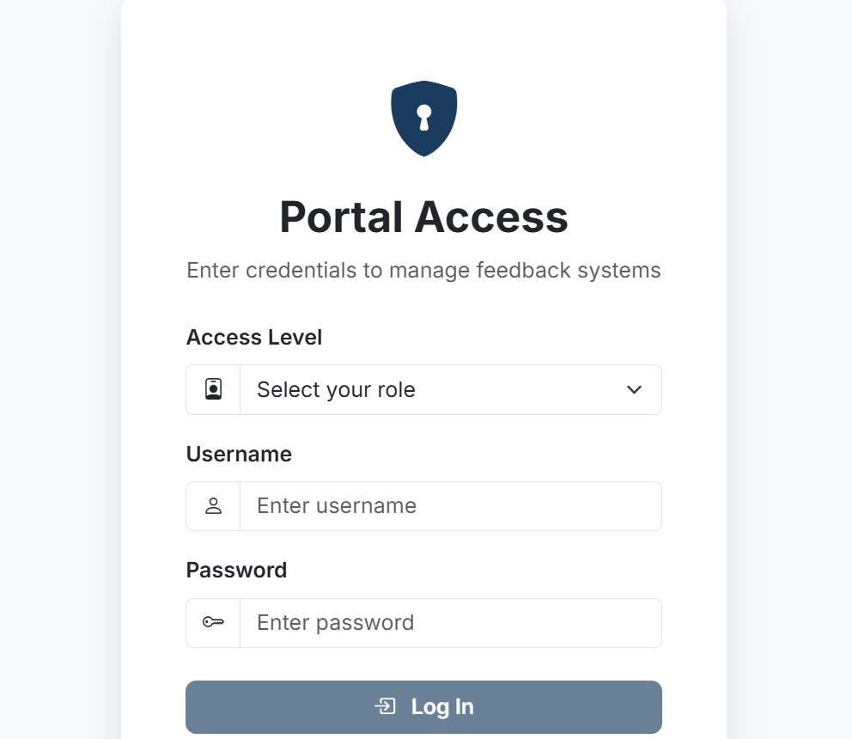

The Login Page for User & Admin

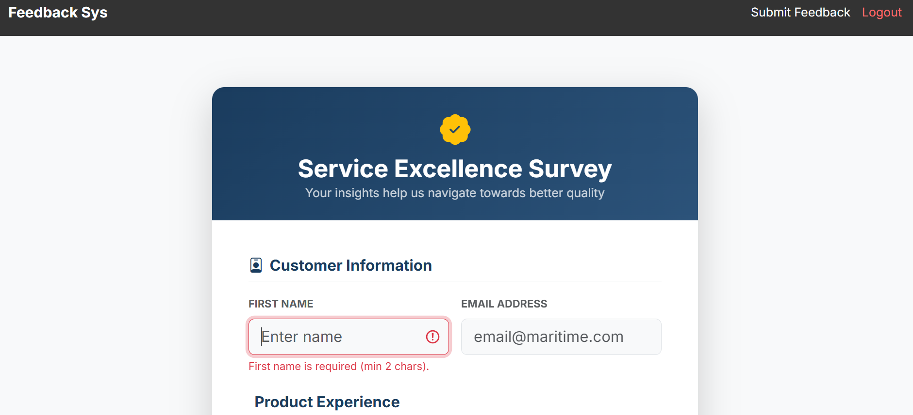

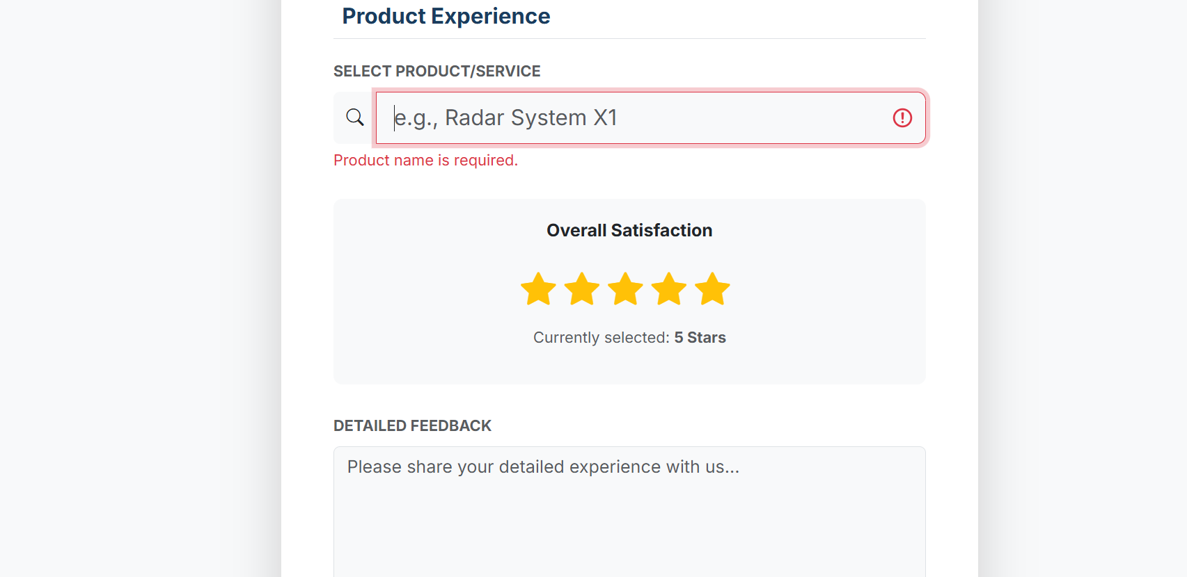

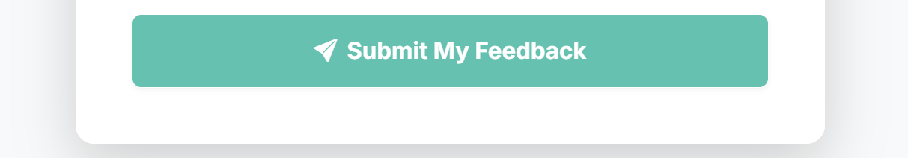

Feedback Form

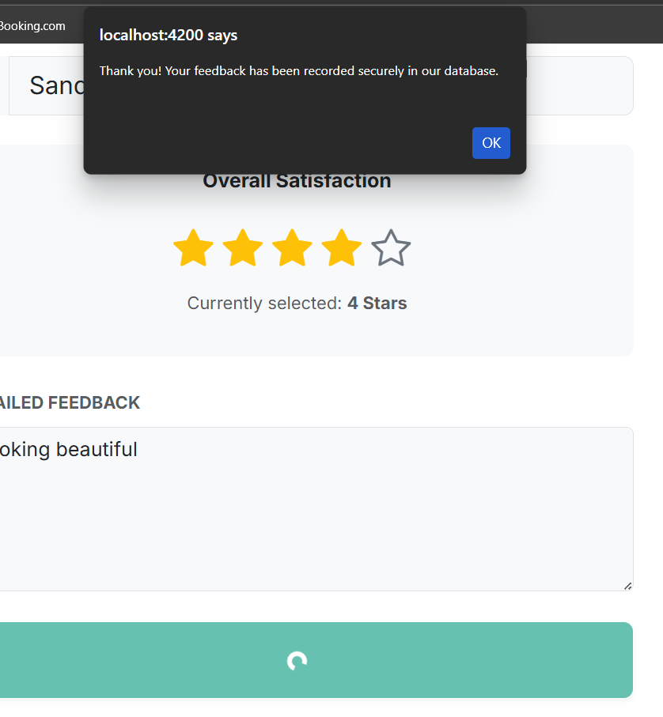

Feedback Submitted Message

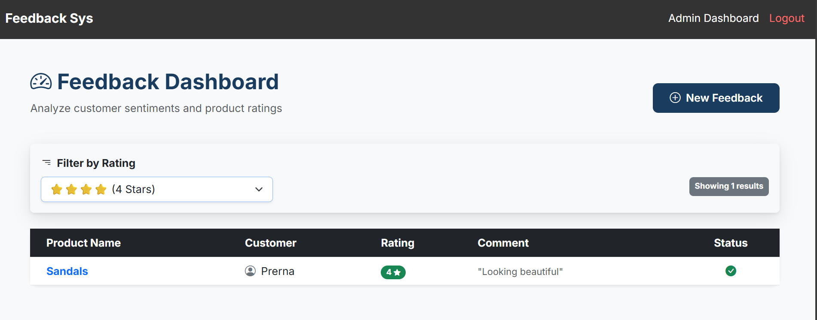

Admin Dashboard to view & filter feedback

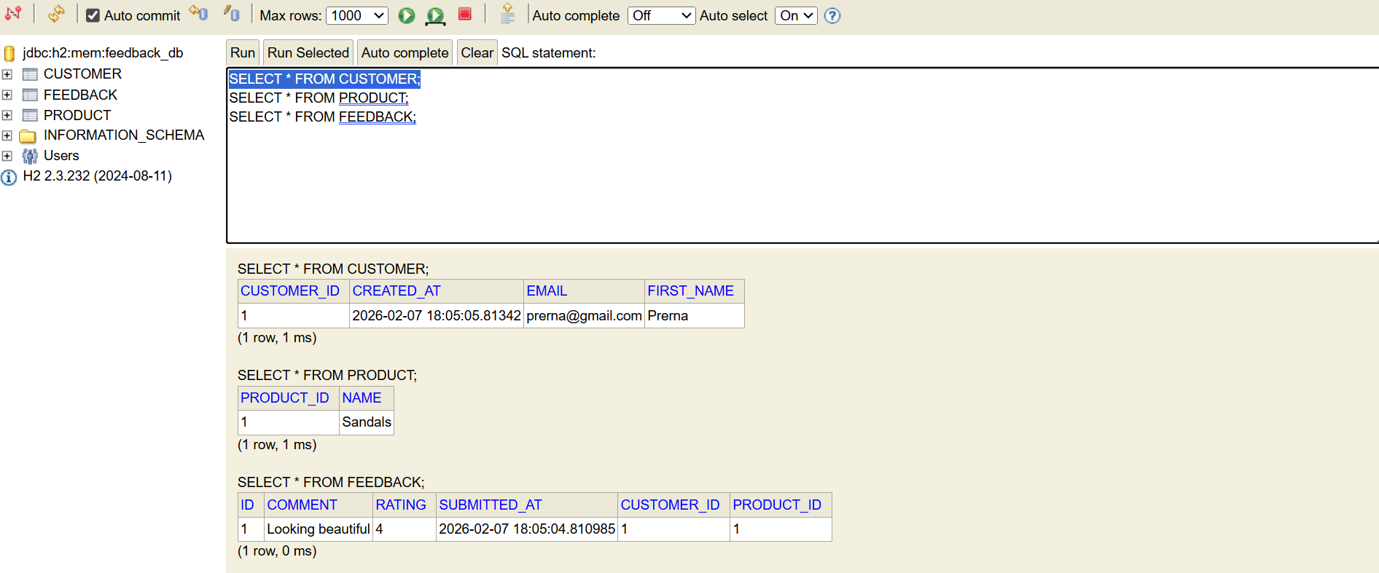

Data storing at database

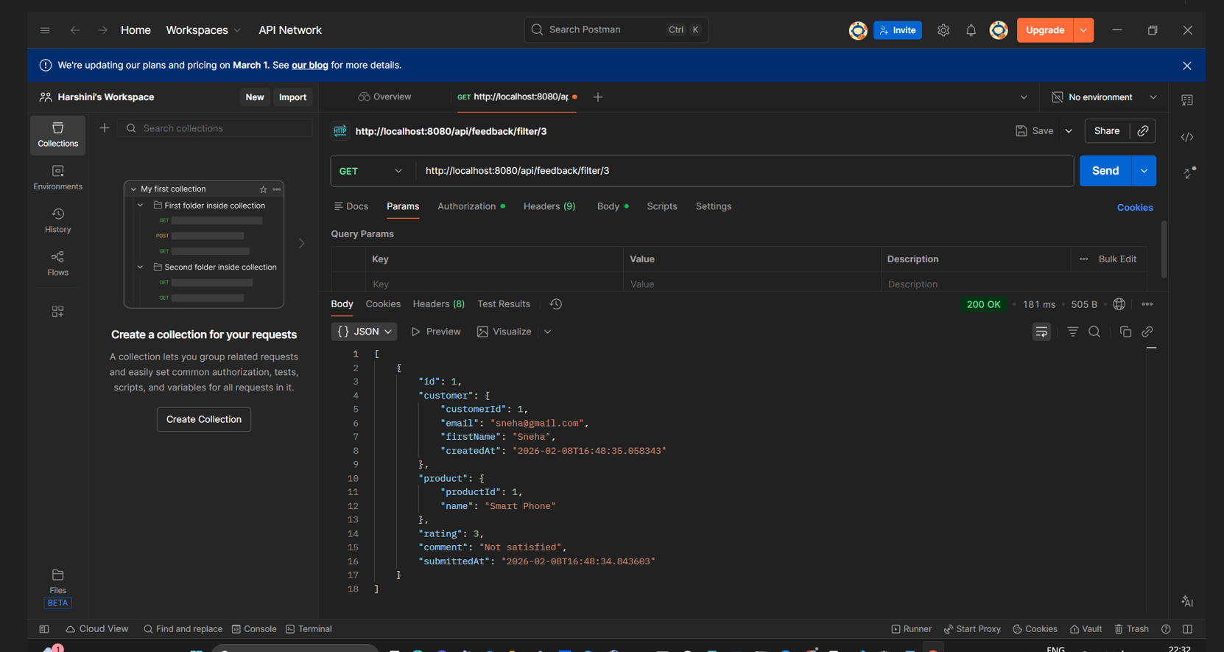

Postman screenshot for GET method to filter feedback records by rating

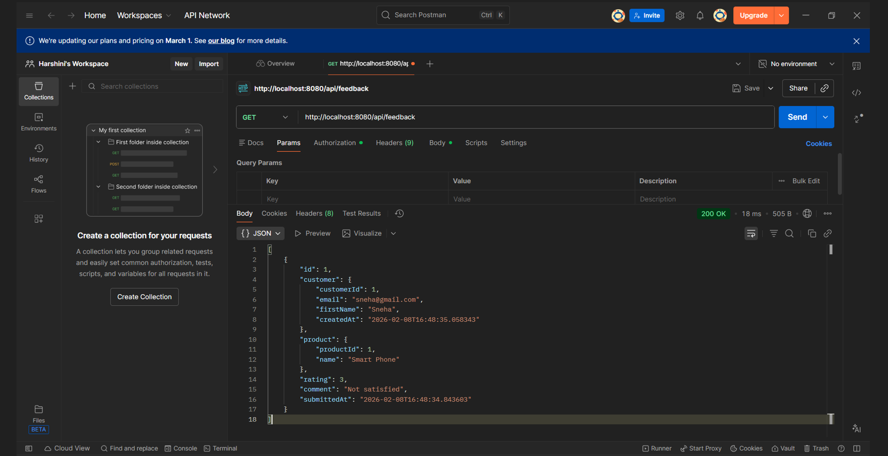

Postman screenshot for GET method to view all feedback records

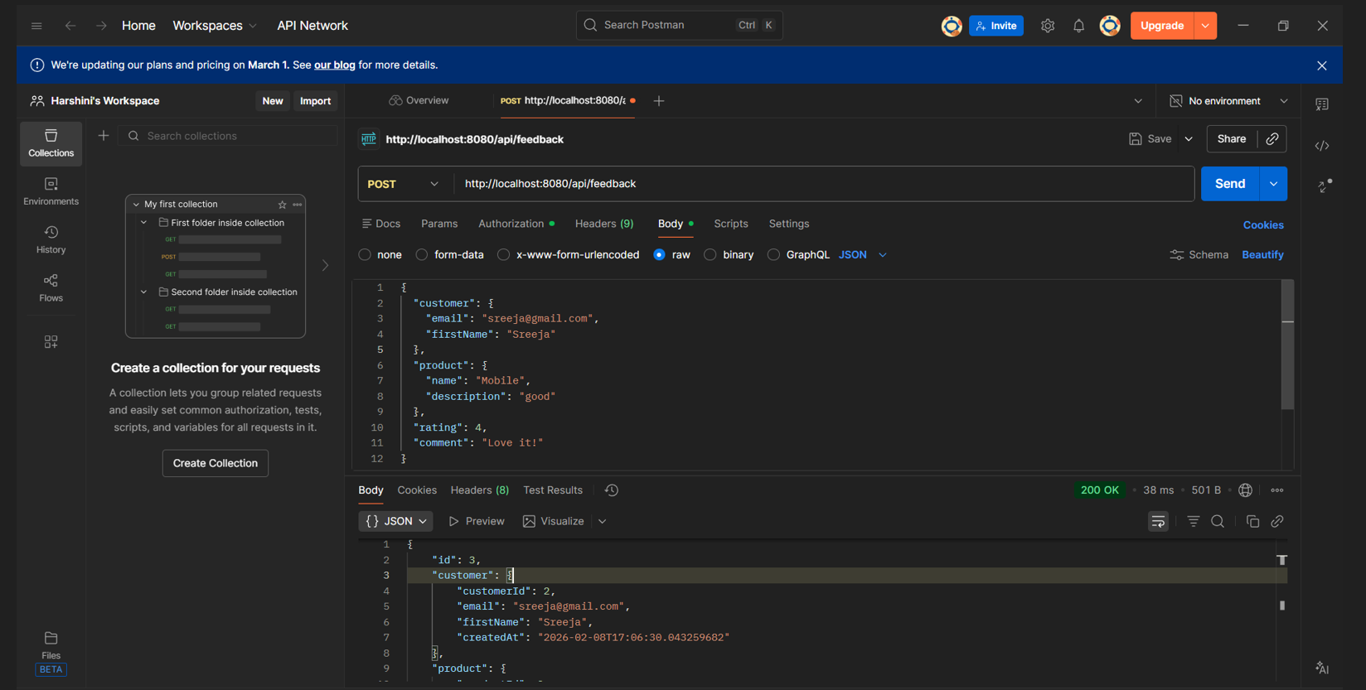

Postman screenshot for POST method to submit/add feedback record

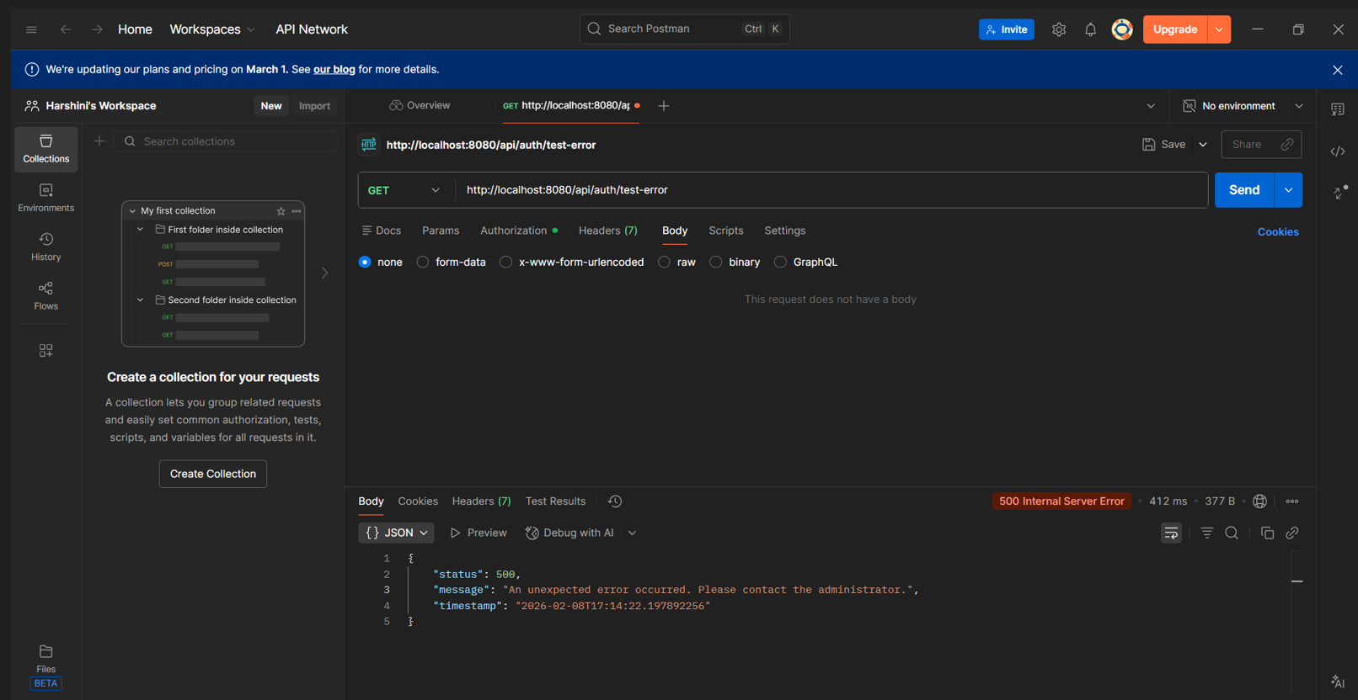

Postman screenshot for GET method to check the global exceptional handling that is used